# IMS Engineering College, Ghaziabad

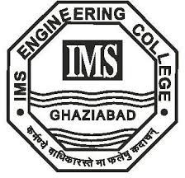

**Resume Builder**

**Subject Name: Mini Project Subject Code: KCS-354**

COURSE : B.Tech.

SEMESTER : 3rd

# By

PRATEEKSHIT JAISWAL (2101430100130)

Department of Computer Science and Engineering IMS ENGINEERING COLLEGE

NH-09, Adhyatmik Nagar, Ghaziabad-201015 (2022-23)